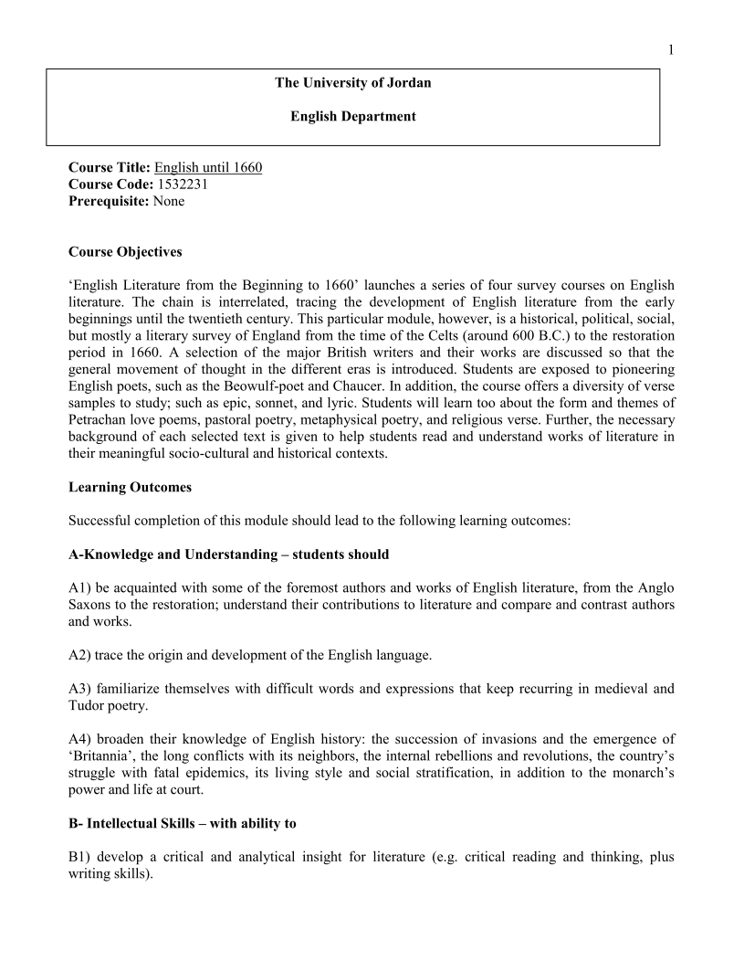

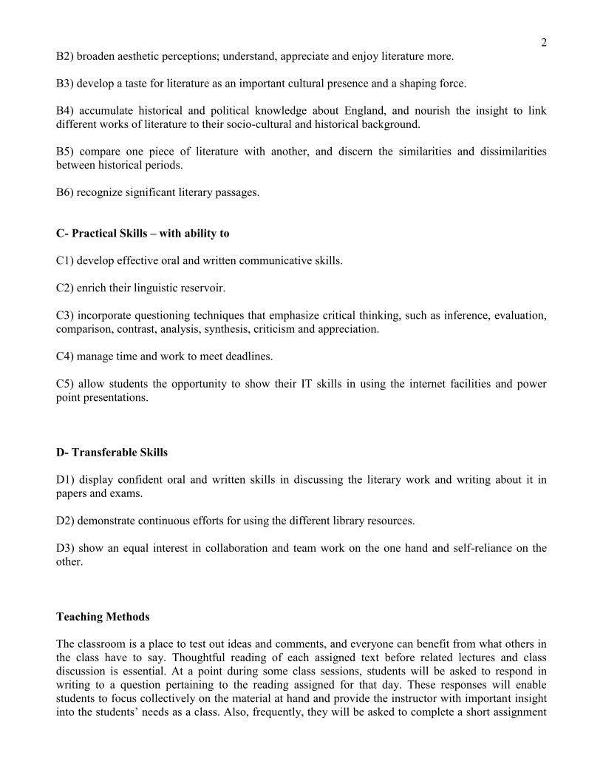

WEEK | READING & STUDY | ASSESSMENT
First | Pre-Anglo-Saxon invasion
Second | Anglo-Saxon invasion
Third | Beowulf
Fourth | Beowulf
Fifth | Medieval period of English Literature (1066-1485)  - The Norman Conquest, the end of Anglo Saxon period  - The Roman Catholic Church  - Characteristics of Medieval Literature | Quiz
Sixth | - The Miracle Play  - The Morality play  - The Ballad
Seventh | William Langland  William Caxton  Sir Gawain and the Green Knight | St’s group Presentations
Eighth | The Morality Play  EVERYMAN | Midterm Exam
Ninth | Chaucer's age  - The Prologue of The Canterbury Tales  - The Wife of Bath’s Tale | St’s group Presentations
Tenth | The Renaissance Period: 1550–1660  - Literature and the Age | St’s group Presentations
Eleventh | - Edmund Spenser (My love is Like to ice)  - Edmund Spenser (Sonnet 54)  - Christopher Marlowe (Whoever Loved That Loved Not At First Sight) | St’s group Presentations
Twelfth | - Sir Philip Sidney (Loving in Truth)  - John Donne (Death Be Not Proud)  - George Herbert (The Pulley) | St’s group Presentations
Thirteenth | - Andrew Marvell (A Dialogue between the Soul and the Body) | St’s group Presentations
Fourteenth | - Introduction Elizabethan Age, theatre and drama  - William Shakespeare (Sonnet 73)  - William Shakespeare (Sonnet 18) | St’s group Presentations
Fifteenth | - John Milton (Lycidas)  - John Milton (On his blindness) | St’s group Presentations
Sixteen | Introduction to Restoration era (to be continued in another course. | Final Exam
Evaluation:
- Students’ presentations and class handouts 10%
- Quiz 10%
- Participation and attendance 10%
- Midterm Exam 30%
- Final exam 40%

Contact and Office hours
- Email: a.shomar@ju.edu.jo
- Office: Sun. Tues. & Thurs. from 11:00 to 12:00 / Mon. & Wed. from 11:30 to 12:30

